**audio mixing using MAX98357A**

***audio mixing from SPIFFS***:  
the following is a guide on how to stream a mixed audio using the MAX98357A amplifier and ESP32’s SPIFFS. for this tutorial, we used the Arduino IDE.  
**assumptions:**

* you have downloaded the Arduino IDE.
* you have configured the IDE to work with the “DOIT ESP32 DIVKIT V1” board.
* you know how to upload files to ESP32’s SPIFFS.

a guide to all the steps above can be found in the “bank of knowledge”.

**needed material:**

* ESP32 microcontroller
* MAX98357A amplifier
* breadboard
* WiFi connection
* 6 wires
* a speaker that works with a 3[WATT]/4Ω

**NOTE: the mixed sound’s quality is not good because:**

* SPIFFS memory size is small, so the audio files’ sizes to be used will be short (2-3 seconds each).
* we’re using only one module of the MAX98357A .  
  for a much better result, use an SD card for larger audio files, and 2 modules of the MAX98357A for stereo mode. a guide on how to do so is provided after this one.
* the bit-depth(encoding) to be used in our case should be 16-bits

**step 1:** upload the audio files “wav1_16.wav” and “wav2_16.wav” to your esp32’s SPIFFS.

**step 2:** setup the wiring as follows:

|  |  |
| --- | --- |
| **MAX98357A** | **ESP32** |
| Vin (2.5V-5.5V) | Vcc (preferably 3.3V but can be 5V) |
| GND | GND |
| BCK or BCLK | Pin 27 (G27) |
| DIN | Pin 25 (G25) |
| LRC | Pin 26 (G26) |
| GAIN | 3.3V |
| SD | - |

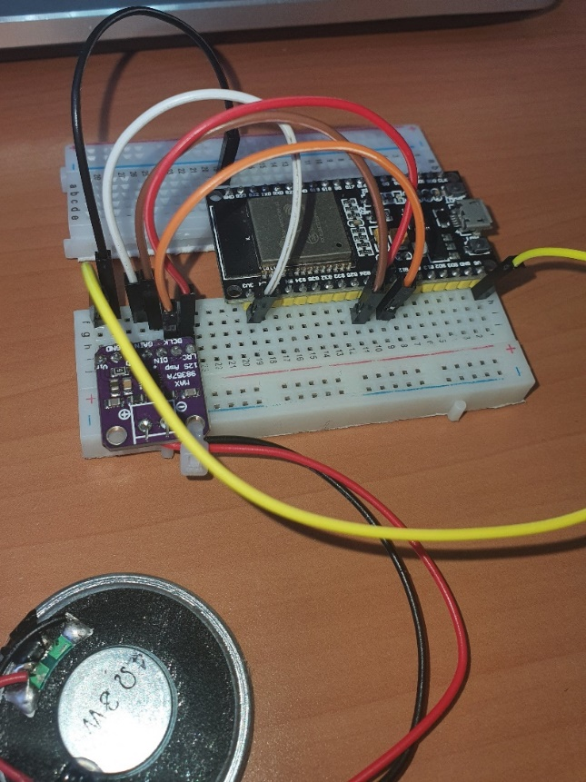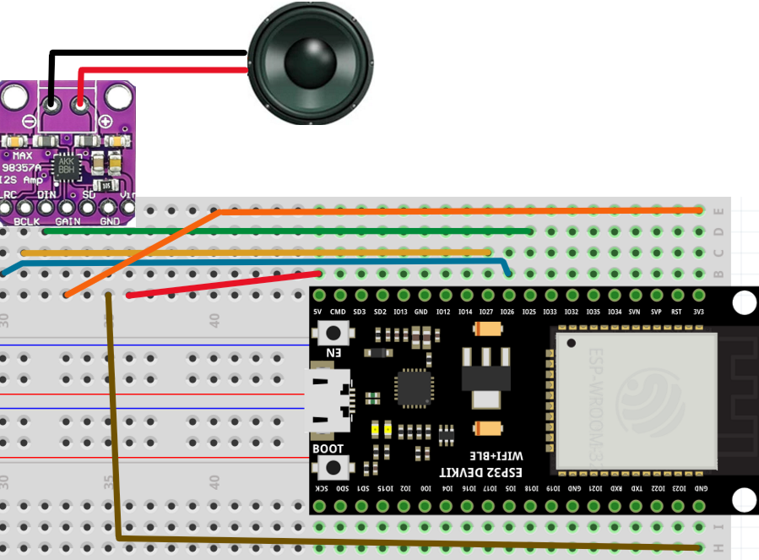

**step 3:** copy and paste the following code (the code is also provided in file of its own):

//------------------------------------------------------------------------------------------------------------------------  
//   
// Title: SPIFFS Wav Player With Mixing  
//  
// Description:  
// Simple example to demonstrate the fundamentals of mixing WAV files (digitized sound) from SPIFFS via the I2S   
// interface of the ESP32. To keep this simple the WAVs must be stereo and 16bit samples.   
// The Samples Per second can be anything. On the SD Card the wav file must be in root and called wav1_16.wav and  
// wav2_16.wav. wav1_16.wav will play repeatedly and wav2_16.wav will play when a designated pin on the ESP32  
// is grounded.  
// Libraries are available to play WAV's on ESP32, this code does not use these so that we can see what is happening.  
//  
// use the code as you wish, no warranty is provided, It is not listed as fit for any purpose you perceive  
// It may damage your house, steal your lover, drink your beers and more.  
//  
//------------------------------------------------------------------------------------------------------------------------  
  
  
//------------------------------------------------------------------------------------------------------------------------  
//  
// Includes  
  
 #include "SPIFFS.h"  
 #include "driver/i2s.h" // Library of I2S routines, comes with ESP32 standard install  
   
//------------------------------------------------------------------------------------------------------------------------  
  
  
//------------------------------------------------------------------------------------------------------------------------  
// Defines  
  
// Volume control  
 #define POT_VOL_ANALOG_IN 14 // Pin that will connect to the middle pin of the potentiometer.  
   
// I2S  
 #define I2S_DOUT 25 // i2S Data out oin  
 #define I2S_BCLK 27 // Bit clock  
 #define I2S_LRC 26 // Left/Right clock, also known as Frame clock or word select  
 #define I2S_NUM 0 // i2s port number  
  
// Wav File reading  
 #define NUM_BYTES_TO_READ_FROM_FILE 1024 // How many bytes to read from wav file at a time  
  
//------------------------------------------------------------------------------------------------------------------------  
  
//------------------------------------------------------------------------------------------------------------------------  
// structures and also variables  
// I2S configuration  
  
 static const i2s_config_t i2s_config =   
 {  
 .mode = (i2s_mode_t)(I2S_MODE_MASTER | I2S_MODE_TX),  
 .sample_rate = 44100, // Note, all files must be this  
 .bits_per_sample = I2S_BITS_PER_SAMPLE_16BIT,  
 .channel_format = I2S_CHANNEL_FMT_RIGHT_LEFT,  
 .communication_format = (i2s_comm_format_t)(I2S_COMM_FORMAT_I2S | I2S_COMM_FORMAT_I2S_MSB),  
 .intr_alloc_flags = ESP_INTR_FLAG_LEVEL1, // high interrupt priority  
 .dma_buf_count = 8, // 8 buffers  
 .dma_buf_len = 256, // 256 bytes per buffer, so 2K of buffer space  
 .use_apll=0,  
 .tx_desc_auto_clear= true,   
 .fixed_mclk=-1   
 };  
   
 // These are the physical wiring connections to our I2S decoder board/chip from the esp32, there are other connections  
 // required for the chips mentioned at the top (but not to the ESP32), please visit the page mentioned at the top for  
 // further information regarding these other connections.  
   
 static const i2s_pin_config_t pin_config =   
 {  
 .bck_io_num = I2S_BCLK, // The bit clock connectiom, goes to pin 27 of ESP32  
 .ws_io_num = I2S_LRC, // Word select, also known as word select or left right clock  
 .data_out_num = I2S_DOUT, // Data out from the ESP32, connect to DIN on 38357A  
 .data_in_num = I2S_PIN_NO_CHANGE // we are not interested in I2S data into the ESP32  
 };  
   
 struct WavHeader_Struct  
 {  
 // RIFF Section   
 char RIFFSectionID[4]; // Letters "RIFF"  
 uint32_t Size; // Size of entire file less 8  
 char RiffFormat[4]; // Letters "WAVE"  
   
 // Format Section   
 char FormatSectionID[4]; // letters "fmt"  
 uint32_t FormatSize; // Size of format section less 8  
 uint16_t FormatID; // 1=uncompressed PCM  
 uint16_t NumChannels; // 1=mono,2=stereo  
 uint32_t SampleRate; // 44100, 16000, 8000 etc.  
 uint32_t ByteRate; // =SampleRate * Channels * (BitsPerSample/8)  
 uint16_t BlockAlign; // =Channels * (BitsPerSample/8)  
 uint16_t BitsPerSample; // 8,16,24 or 32  
   
 // Data Section  
 char DataSectionID[4]; // The letters "data"  
 uint32_t DataSize; // Size of the data that follows  
 };  
  
 // The data for one particular wav file  
 struct Wav_Struct  
 {  
 File WavFile; // Object for accessing the opened wavfile  
 uint32_t DataSize; // Size of wav file data  
 bool Playing=false; // Is file playing  
 bool Repeat; // If true, when wav ends, it will auto start again  
 byte Samples[NUM_BYTES_TO_READ_FROM_FILE]; // Buffer to store data red from file  
 uint32_t TotalBytesRead=0; // Number of bytes read from file so far  
 uint16_t LastNumBytesRead; // Num bytes actually read from the wav file which will either be  
 // NUM_BYTES_TO_READ_FROM_FILE or less than this if we are very  
 // near the end of the file. i.e. we can't read beyond the file.  
   
 };  
//------------------------------------------------------------------------------------------------------------------------  
  
// Global Variables/objects   
   
 static const i2s_port_t i2s_num = I2S_NUM_0; // i2s port number   
 Wav_Struct Wav1; // Main Wave to play  
 Wav_Struct Wav2; // Secondary "short" wav   
 float Volume; // Volume  
  
//------------------------------------------------------------------------------------------------------------------------  
  
  
void setup() {   
 Serial.begin(115200); // Used for info/debug  
 // Mount the SPIFFS file system  
 if (!SPIFFS.begin(true)) {  
 Serial.println("Failed to mount file system");  
 return;  
 }  
 i2s_driver_install(i2s_num, &i2s_config, 0, NULL);  
 i2s_set_pin(i2s_num, &pin_config);  
 if(InitWavFiles()==false)  
 while(true); // If a problem terminate program   
 Wav1.Repeat=true; // Wav1 will auto repeat  
 Wav1.Playing=true; // We set wav1 to play comtinuously   
 Wav2.Repeat=true; // Wav2 will auto repeat  
 Wav2.Playing=true; // We set wav2 to play comtinuously  
}  
  
  
void loop()  
{   
 PlayWavs(); // Have to keep calling this to keep the wav file playing  
 // Your normal code to do your task can go here  
}  
  
void PlayWavs()  
{  
 static bool ReadingFile=true; // True if reading files from SD. false if filling I2S buffer  
 static byte Samples[NUM_BYTES_TO_READ_FROM_FILE]; // Memory allocated to store the data read in from the wav files  
 static uint16_t BytesReadFromFile; // Max Num bytes actually read from the wav files which will either be  
 // NUM_BYTES_TO_READ_FROM_FILE or less than this if we are very  
 // near the end of all files.  
  
 Volume=float(analogRead(POT_VOL_ANALOG_IN))/2047; // You possibly don't need to sample volume this often, perhaps every 1/10 sec would be fine  
 if(ReadingFile) // Read next chunk of data in from files   
 {  
 ReadFiles(); // Read data into the wavs own buffers  
 BytesReadFromFile=MixWavs(Samples); // Mix the samples together and store in the samples buffer  
 ReadingFile=false; // Switch to sending the buffer to the I2S  
 }  
 else  
 ReadingFile=FillI2SBuffer(Samples,BytesReadFromFile); // We keep calling this routine until it returns true, at which point  
 // this will swap us back to Reading the next block of data from the file.  
 // Reading true means it has managed to push all the data to the I2S   
 // Handler, false means there still more to do and you should call this  
 // routine again and again until it returns true.  
}  
  
uint16_t MixWavs(byte* Samples)  
{  
 // Mix all playing wavs together, returns the max bytes that are in the buffer, usually this would be the full buffer but  
 // in rare cases wavs may be close to the end of the file and thus not fill the entire buffer   
  
 uint16_t Wav1Idx,Wav2Idx; // Index into the wavs sample data  
 int16_t Sample; // The mixed sample  
 uint16_t i; // index into main samples buffer  
 uint16_t MaxBytesInBuffer; // Max bytes of data in buffer, most of time buffer will be full  
   
 Wav1Idx=0;  
 Wav2Idx=0;  
 while((Wav1Idx<Wav1.LastNumBytesRead)|(Wav2Idx<Wav2.LastNumBytesRead))  
 {  
 Sample=0;  
 if(Wav1.Playing)

Sample=*((int16_t *)(Wav1.Samples+Wav1Idx));   
 if(Wav2.Playing)  
 Sample+=*((int16_t *)(Wav2.Samples+Wav2Idx)); // This does the actual mix, just add togther  
 *((int16_t *)(Samples+i))=Sample;  
 Wav1Idx+=2;  
 Wav2Idx+=2;  
 i+=2;  
 }  
 if(Wav1.LastNumBytesRead>Wav2.LastNumBytesRead)  
 MaxBytesInBuffer=Wav1.LastNumBytesRead;  
 else  
 MaxBytesInBuffer=Wav2.LastNumBytesRead;  
   
 // We now alter the data according to the volume control  
 for(i=0;i<MaxBytesInBuffer;i+=2) // We step 2 bytes at a time as we're using 16bits per channel  
 *((int16_t *)(Samples+i))=(*((int16_t *)(Samples+i)))*(0.1);   
 //*((int16_t *)(Samples+i))=(*((int16_t *)(Samples+i)))*Volume;   
  
 return MaxBytesInBuffer;  
}  
  
  
bool InitWavFiles()  
{  
 // initialise wav files   
 if(LoadWavFileHeader("/wav1_16.wav",&Wav1))  
 return LoadWavFileHeader("/wav2_16.wav",&Wav2); // only bother trying to load this if first loads ok  
 else  
 return false;   
}  
  
  
void ReadFiles()  
{  
 // Read in all files samples into their buffers   
 if(Wav1.Playing)  
 ReadFile(&Wav1);  
 if(Wav2.Playing)  
 ReadFile(&Wav2);  
}  
  
void ReadFile(Wav_Struct *Wav)  
{  
 uint16_t i; // loop counter  
 int16_t SignedSample; // Single Signed Sample  
 float Volume;   
   
 if(Wav->TotalBytesRead+NUM_BYTES_TO_READ_FROM_FILE>Wav->DataSize) // If next read will go past the end then adjust the   
 Wav->LastNumBytesRead=Wav->DataSize-Wav->TotalBytesRead; // amount to read to whatever is remaining to read  
 else  
 Wav->LastNumBytesRead=NUM_BYTES_TO_READ_FROM_FILE; // Default to max to read  
   
 Wav->WavFile.read(Wav->Samples,Wav->LastNumBytesRead); // Read in the bytes from the file  
 Wav->TotalBytesRead+=Wav->LastNumBytesRead; // Update the total bytes red in so far  
   
 if(Wav->TotalBytesRead>=Wav->DataSize) // Have we read in all the data?  
 {  
 if(Wav->Repeat)  
 {  
 Wav->WavFile.seek(44); // Reset to start of wav data   
 Wav->TotalBytesRead=0; // Clear to no bytes read in so far   
 }   
 else  
 Wav->Playing=false; // Flag that wav has completed  
 }  
}  
  
bool LoadWavFileHeader(String FileName, Wav_Struct* Wav)  
{  
 // Load wav file, if all goes ok returns true else false  
 WavHeader_Struct WavHeader;   
  
 Wav->WavFile = SPIFFS.open(FileName); // Open the wav file  
 if(Wav->WavFile==false)  
 {  
 Serial.print("Could not open :");  
 Serial.println(FileName);  
 return false;  
 }  
 else  
 {  
 Wav->WavFile.read((byte *) &WavHeader,44); // Read in the WAV header, which is first 44 bytes of the file.   
 // We have to typecast to bytes for the "read" function  
 if(ValidWavData(&WavHeader))  
 {  
 DumpWAVHeader(&WavHeader); // Dump the header data to serial, optional!  
 Serial.println();  
 Wav->DataSize=WavHeader.DataSize; // Copy the data size into our wav structure  
 return true;  
 }  
 else  
 return false;  
 }  
}  
  
  
  
bool FillI2SBuffer(byte* Samples,uint16_t BytesInBuffer)  
{  
 // Writes bytes to buffer, returns true if all bytes sent else false, keeps track itself of how many left  
 // to write, so just keep calling this routine until returns true to know they've all been written, then  
 // you can re-fill the buffer  
   
 size_t BytesWritten; // Returned by the I2S write routine,   
 static uint16_t BufferIdx=0; // Current pos of buffer to output next  
 uint8_t* DataPtr; // Point to next data to send to I2S  
 uint16_t BytesToSend; // Number of bytes to send to I2S  
   
 // To make the code eaier to understand I'm using to variables to some calculations, normally I'd write this calcs  
 // directly into the line of code where they belong, but this make it easier to understand what's happening  
   
 DataPtr=Samples+BufferIdx; // Set address to next byte in buffer to send out  
 BytesToSend=BytesInBuffer-BufferIdx; // This is amount to send (total less what we've already sent)  
 i2s_write(i2s_num,DataPtr,BytesToSend,&BytesWritten,1); // Send the bytes, wait 1 RTOS tick to complete  
 BufferIdx+=BytesWritten; // increasue by number of bytes actually written  
   
 if(BufferIdx>=BytesInBuffer)   
 {  
 // sent out all bytes in buffer, reset and return true to indicate this  
 BufferIdx=0;   
 return true;   
 }  
 else  
 return false; // Still more data to send to I2S so return false to indicate this  
}  
  
bool ValidWavData(WavHeader_Struct* Wav)  
{  
   
 if(memcmp(Wav->RIFFSectionID,"RIFF",4)!=0)   
 {   
 Serial.print("Invalid data - Not RIFF format");  
 return false;   
 }  
 if(memcmp(Wav->RiffFormat,"WAVE",4)!=0)  
 {  
 Serial.print("Invalid data - Not Wave file");  
 return false;   
 }  
 if(memcmp(Wav->FormatSectionID,"fmt",3)!=0)   
 {  
 Serial.print("Invalid data - No format section found");  
 return false;   
 }  
 if(memcmp(Wav->DataSectionID,"data",4)!=0)   
 {  
 Serial.print("Invalid data - data section not found");  
 return false;   
 }  
 if(Wav->FormatID!=1)   
 {  
 Serial.print("Invalid data - format Id must be 1");  
 return false;   
 }  
 if(Wav->FormatSize!=16)   
 {  
 Serial.print("Invalid data - format section size must be 16.");  
 return false;   
 }  
 if((Wav->NumChannels!=1)&(Wav->NumChannels!=2))  
 {  
 Serial.print("Invalid data - only mono or stereo permitted.");  
 return false;   
 }  
 if(Wav->SampleRate>48000)   
 {  
 Serial.print("Invalid data - Sample rate cannot be greater than 48000");  
 return false;   
 }  
 if((Wav->BitsPerSample!=8)& (Wav->BitsPerSample!=16))   
 {  
 Serial.print("Invalid data - Only 8 or 16 bits per sample permitted.");  
 return false;   
 }  
 return true;  
}  
  
  
void DumpWAVHeader(WavHeader_Struct* Wav)  
{  
 if(memcmp(Wav->RIFFSectionID,"RIFF",4)!=0)  
 {  
 Serial.print("Not a RIFF format file - ");   
 PrintData(Wav->RIFFSectionID,4);  
 return;  
 }   
 if(memcmp(Wav->RiffFormat,"WAVE",4)!=0)  
 {  
 Serial.print("Not a WAVE file - ");   
 PrintData(Wav->RiffFormat,4);   
 return;  
 }   
 if(memcmp(Wav->FormatSectionID,"fmt",3)!=0)  
 {  
 Serial.print("fmt ID not present - ");  
 PrintData(Wav->FormatSectionID,3);   
 return;  
 }   
 if(memcmp(Wav->DataSectionID,"data",4)!=0)  
 {  
 Serial.print("data ID not present - ");   
 PrintData(Wav->DataSectionID,4);  
 return;  
 }   
 // All looks good, dump the data  
 Serial.print("Total size :");Serial.println(Wav->Size);  
 Serial.print("Format section size :");Serial.println(Wav->FormatSize);  
 Serial.print("Wave format :");Serial.println(Wav->FormatID);  
 Serial.print("Channels :");Serial.println(Wav->NumChannels);  
 Serial.print("Sample Rate :");Serial.println(Wav->SampleRate);  
 Serial.print("Byte Rate :");Serial.println(Wav->ByteRate);  
 Serial.print("Block Align :");Serial.println(Wav->BlockAlign);  
 Serial.print("Bits Per Sample :");Serial.println(Wav->BitsPerSample);  
 Serial.print("Data Size :");Serial.println(Wav->DataSize);  
}  
  
void PrintData(const char* Data,uint8_t NumBytes)  
{  
 for(uint8_t i=0;i<NumBytes;i++)  
 Serial.print(Data[i]);   
 Serial.println();   
}

**Important Notes:**

* make sure that the defined Pins match the wiring!
* in the function “InitWavFiles()”, make sure the name of the audio files matches the ones you want to you use from your SPIFFS.
* the “MixWavs” function is the star function here, that’s where the actual mixing occurs!
* if you look at the following part in that function :  
   if(Wav1.Playing)   
   Sample=*((int16_t *)(Wav1.Samples+Wav1Idx));   
   if(Wav2.Playing)  
   Sample+=*((int16_t *)(Wav2.Samples+Wav2Idx));

you can comment the second\fourth lines to hear only one of the audio files playing.

* in the same function “MixWav”, right before exiting, there is a value that is multiplied by the variable “VOLUME”, that’s the variable that is responsible of the mixed audio’s volume, change it accordingly, recommended values are “0 < VOLUME < 1”

**step 4:** connect the ESP32 to your computer, compile and run the code. you might need to press on the “reset” button on your ESP32.

**step 5:** enjoy the mixed sound 😊

***audio mixing from SD card & 2 modules of the amplifier***:  
the following is a guide on how to stream a mixed audio using 2 MAX98357A amplifiers, SD Card and ESP32. for this tutorial, we used the Arduino IDE.  
**assumptions:**

* you have downloaded the Arduino IDE.
* you have configured the IDE to work with the “DOIT ESP32 DIVKIT V1” board.

a guide to all the steps above can be found in the “bank of knowledge”.

**needed material:**

* ESP32 microcontroller
* MAX98357A amplifier x 2
* breadboard
* WiFi connection
* wires
* a speaker that works with a 3[WATT]/4Ω x 2
* SD Card
* SD Card adapter

**step 1:** upload the audio files “wav1_16.wav” and “wav2_16.wav” to your SD Card.

**step 2:** setup the wiring as follows:  
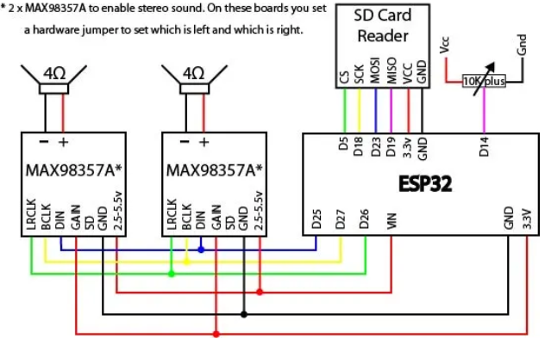

**NOTE: in order to redirect the sound to the right\left channel, check out the “playing audio in mono or stereo using MAX98357A or PCM5102A” guide.**

**step 3:** copy and paste the following code (the code is also provided in file of its own).  
**NOTE:**

* the code is very similar to the one above, but modified to read files from the SD Card instead of SPIFFS.
* the “important notes” stated above also apply here.

//------------------------------------------------------------------------------------------------------------------------  
//   
// Title: SD Card Wav Player With Mixing  
//  
// Description:  
// Simple example to demonstrate the fundamentals of mixing WAV files (digitized sound) from SPIFFS via the I2S   
// interface of the ESP32. To keep this simple the WAVs must be stereo and 16bit samples.   
// The Samples Per second can be anything. On the SD Card the wav file must be in root and called wav1_16.wav and  
// wav2_16.wav. wav1_16.wav will play repeatedly and wav2_16.wav will play when a designated pin on the ESP32  
// is grounded.  
// Libraries are available to play WAV's on ESP32, this code does not use these so that we can see what is happening.  
//  
// use the code as you wish, no warranty is provided, It is not listed as fit for any purpose you perceive  
// It may damage your house, steal your lover, drink your beers and more.  
//  
//------------------------------------------------------------------------------------------------------------------------  
  
  
//------------------------------------------------------------------------------------------------------------------------  
//  
// Includes  
  
 #include "SD.h" // SD Card library, usually part of the standard install  
 #include "driver/i2s.h" // Library of I2S routines, comes with ESP32 standard install  
   
//------------------------------------------------------------------------------------------------------------------------  
  
  
//------------------------------------------------------------------------------------------------------------------------  
// Defines  
  
// Volume control  
 #define POT_VOL_ANALOG_IN 14 // Pin that will connect to the middle pin of the potentiometer.  
   
// SD Card  
 #define SD_CS 5 // SD Card chip select  
   
// I2S  
 #define I2S_DOUT 25 // i2S Data out oin  
 #define I2S_BCLK 27 // Bit clock  
 #define I2S_LRC 26 // Left/Right clock, also known as Frame clock or word select  
 #define I2S_NUM 0 // i2s port number  
  
// Wav File reading  
 #define NUM_BYTES_TO_READ_FROM_FILE 1024 // How many bytes to read from wav file at a time  
  
//------------------------------------------------------------------------------------------------------------------------  
  
//------------------------------------------------------------------------------------------------------------------------  
// structures and also variables  
// I2S configuration  
  
 static const i2s_config_t i2s_config =   
 {  
 .mode = (i2s_mode_t)(I2S_MODE_MASTER | I2S_MODE_TX),  
 .sample_rate = 44100, // Note, all files must be this  
 .bits_per_sample = I2S_BITS_PER_SAMPLE_16BIT,  
 .channel_format = I2S_CHANNEL_FMT_RIGHT_LEFT,  
 .communication_format = (i2s_comm_format_t)(I2S_COMM_FORMAT_I2S | I2S_COMM_FORMAT_I2S_MSB),  
 .intr_alloc_flags = ESP_INTR_FLAG_LEVEL1, // high interrupt priority  
 .dma_buf_count = 8, // 8 buffers  
 .dma_buf_len = 256, // 256 bytes per buffer, so 2K of buffer space  
 .use_apll=0,  
 .tx_desc_auto_clear= true,   
 .fixed_mclk=-1   
 };  
   
 // These are the physical wiring connections to our I2S decoder board/chip from the esp32, there are other connections  
 // required for the chips mentioned at the top (but not to the ESP32), please visit the page mentioned at the top for  
 // further information regarding these other connections.  
   
 static const i2s_pin_config_t pin_config =   
 {  
 .bck_io_num = I2S_BCLK, // The bit clock connectiom, goes to pin 27 of ESP32  
 .ws_io_num = I2S_LRC, // Word select, also known as word select or left right clock  
 .data_out_num = I2S_DOUT, // Data out from the ESP32, connect to DIN on 38357A  
 .data_in_num = I2S_PIN_NO_CHANGE // we are not interested in I2S data into the ESP32  
 };  
   
 struct WavHeader_Struct  
 {  
 // RIFF Section   
 char RIFFSectionID[4]; // Letters "RIFF"  
 uint32_t Size; // Size of entire file less 8  
 char RiffFormat[4]; // Letters "WAVE"  
   
 // Format Section   
 char FormatSectionID[4]; // letters "fmt"  
 uint32_t FormatSize; // Size of format section less 8  
 uint16_t FormatID; // 1=uncompressed PCM  
 uint16_t NumChannels; // 1=mono,2=stereo  
 uint32_t SampleRate; // 44100, 16000, 8000 etc.  
 uint32_t ByteRate; // =SampleRate * Channels * (BitsPerSample/8)  
 uint16_t BlockAlign; // =Channels * (BitsPerSample/8)  
 uint16_t BitsPerSample; // 8,16,24 or 32  
   
 // Data Section  
 char DataSectionID[4]; // The letters "data"  
 uint32_t DataSize; // Size of the data that follows  
 };  
  
 // The data for one particular wav file  
 struct Wav_Struct  
 {  
 File WavFile; // Object for accessing the opened wavfile  
 uint32_t DataSize; // Size of wav file data  
 bool Playing=false; // Is file playing  
 bool Repeat; // If true, when wav ends, it will auto start again  
 byte Samples[NUM_BYTES_TO_READ_FROM_FILE]; // Buffer to store data red from file  
 uint32_t TotalBytesRead=0; // Number of bytes read from file so far  
 uint16_t LastNumBytesRead; // Num bytes actually read from the wav file which will either be  
 // NUM_BYTES_TO_READ_FROM_FILE or less than this if we are very  
 // near the end of the file. i.e. we can't read beyond the file.  
   
 };  
//------------------------------------------------------------------------------------------------------------------------  
  
// Global Variables/objects   
   
 static const i2s_port_t i2s_num = I2S_NUM_0; // i2s port number   
 Wav_Struct Wav1; // Main Wave to play  
 Wav_Struct Wav2; // Secondary "short" wav   
 float Volume; // Volume  
  
//------------------------------------------------------------------------------------------------------------------------  
  
  
void setup() {   
 Serial.begin(115200); // Used for info/debug  
 SDCardInit();  
 i2s_driver_install(i2s_num, &i2s_config, 0, NULL);  
 i2s_set_pin(i2s_num, &pin_config);  
 if(InitWavFiles()==false)  
 while(true); // If a problem terminate program   
 Wav1.Repeat=true; // Wav1 will auto repeat  
 Wav1.Playing=true; // We set wav1 to play comtinuously   
 Wav2.Repeat=true; // Wav2 will auto repeat  
 Wav2.Playing=true; // We set wav2 to play comtinuously  
}  
  
  
void loop()  
{   
 PlayWavs(); // Have to keep calling this to keep the wav file playing  
 // Your normal code to do your task can go here  
}  
  
void PlayWavs()  
{  
 static bool ReadingFile=true; // True if reading files from SD. false if filling I2S buffer  
 static byte Samples[NUM_BYTES_TO_READ_FROM_FILE]; // Memory allocated to store the data read in from the wav files  
 static uint16_t BytesReadFromFile; // Max Num bytes actually read from the wav files which will either be  
 // NUM_BYTES_TO_READ_FROM_FILE or less than this if we are very  
 // near the end of all files.  
  
 Volume=float(analogRead(POT_VOL_ANALOG_IN))/2047; // You possibly don't need to sample volume this often, perhaps every 1/10 sec would be fine  
 if(ReadingFile) // Read next chunk of data in from files   
 {  
 ReadFiles(); // Read data into the wavs own buffers  
 BytesReadFromFile=MixWavs(Samples); // Mix the samples together and store in the samples buffer  
 ReadingFile=false; // Switch to sending the buffer to the I2S  
 }  
 else  
 ReadingFile=FillI2SBuffer(Samples,BytesReadFromFile); // We keep calling this routine until it returns true, at which point  
 // this will swap us back to Reading the next block of data from the file.  
 // Reading true means it has managed to push all the data to the I2S   
 // Handler, false means there still more to do and you should call this  
 // routine again and again until it returns true.  
}  
  
uint16_t MixWavs(byte* Samples)  
{  
 // Mix all playing wavs together, returns the max bytes that are in the buffer, usually this would be the full buffer but  
 // in rare cases wavs may be close to the end of the file and thus not fill the entire buffer   
  
 uint16_t Wav1Idx,Wav2Idx; // Index into the wavs sample data  
 int16_t Sample; // The mixed sample  
 uint16_t i; // index into main samples buffer  
 uint16_t MaxBytesInBuffer; // Max bytes of data in buffer, most of time buffer will be full  
   
 Wav1Idx=0;  
 Wav2Idx=0;  
 while((Wav1Idx<Wav1.LastNumBytesRead)|(Wav2Idx<Wav2.LastNumBytesRead))  
 {  
 Sample=0;  
 if(Wav1.Playing)  
 Sample=*((int16_t *)(Wav1.Samples+Wav1Idx));  
 if(Wav2.Playing)  
 Sample+=*((int16_t *)(Wav2.Samples+Wav2Idx)); // This does the actual mix, just add togther  
 *((int16_t *)(Samples+i))=Sample;  
 Wav1Idx+=2;  
 Wav2Idx+=2;  
 i+=2;  
 }  
 if(Wav1.LastNumBytesRead>Wav2.LastNumBytesRead)  
 MaxBytesInBuffer=Wav1.LastNumBytesRead;  
 else  
 MaxBytesInBuffer=Wav2.LastNumBytesRead;  
   
 // We now alter the data according to the volume control  
 for(i=0;i<MaxBytesInBuffer;i+=2) // We step 2 bytes at a time as we're using 16bits per channel  
 *((int16_t *)(Samples+i))=(*((int16_t *)(Samples+i)))*Volume;   
  
 return MaxBytesInBuffer;  
}  
  
  
bool InitWavFiles()  
{  
 // initialise wav files   
 if(LoadWavFileHeader("/wav1_16.wav",&Wav1))  
 return LoadWavFileHeader("/wav2_16.wav",&Wav2); // only bother trying to load this if first loads ok  
 else  
 return false;   
}  
  
  
void ReadFiles()  
{  
 // Read in all files samples into their buffers   
 if(Wav1.Playing)  
 ReadFile(&Wav1);  
 if(Wav2.Playing)  
 ReadFile(&Wav2);  
}  
  
void ReadFile(Wav_Struct *Wav)  
{  
 uint16_t i; // loop counter  
 int16_t SignedSample; // Single Signed Sample  
 float Volume;   
   
 if(Wav->TotalBytesRead+NUM_BYTES_TO_READ_FROM_FILE>Wav->DataSize) // If next read will go past the end then adjust the   
 Wav->LastNumBytesRead=Wav->DataSize-Wav->TotalBytesRead; // amount to read to whatever is remaining to read  
 else  
 Wav->LastNumBytesRead=NUM_BYTES_TO_READ_FROM_FILE; // Default to max to read  
   
 Wav->WavFile.read(Wav->Samples,Wav->LastNumBytesRead); // Read in the bytes from the file  
 Wav->TotalBytesRead+=Wav->LastNumBytesRead; // Update the total bytes red in so far  
   
 if(Wav->TotalBytesRead>=Wav->DataSize) // Have we read in all the data?  
 {  
 if(Wav->Repeat)  
 {  
 Wav->WavFile.seek(44); // Reset to start of wav data   
 Wav->TotalBytesRead=0; // Clear to no bytes read in so far   
 }   
 else  
 Wav->Playing=false; // Flag that wav has completed  
 }  
}  
  
bool LoadWavFileHeader(String FileName, Wav_Struct* Wav)  
{  
 // Load wav file, if all goes ok returns true else false  
 WavHeader_Struct WavHeader;   
  
 Wav->WavFile = SD.open(FileName); // Open the wav file  
 if(Wav->WavFile==false)  
 {  
 Serial.print("Could not open :");  
 Serial.println(FileName);  
 return false;  
 }  
 else  
 {  
 Wav->WavFile.read((byte *) &WavHeader,44); // Read in the WAV header, which is first 44 bytes of the file.   
 // We have to typecast to bytes for the "read" function  
 if(ValidWavData(&WavHeader))  
 {  
 DumpWAVHeader(&WavHeader); // Dump the header data to serial, optional!  
 Serial.println();  
 Wav->DataSize=WavHeader.DataSize; // Copy the data size into our wav structure  
 return true;  
 }  
 else  
 return false;  
 }  
}  
  
  
  
bool FillI2SBuffer(byte* Samples,uint16_t BytesInBuffer)  
{  
 // Writes bytes to buffer, returns true if all bytes sent else false, keeps track itself of how many left  
 // to write, so just keep calling this routine until returns true to know they've all been written, then  
 // you can re-fill the buffer  
   
 size_t BytesWritten; // Returned by the I2S write routine,   
 static uint16_t BufferIdx=0; // Current pos of buffer to output next  
 uint8_t* DataPtr; // Point to next data to send to I2S  
 uint16_t BytesToSend; // Number of bytes to send to I2S  
   
 // To make the code eaier to understand I'm using to variables to some calculations, normally I'd write this calcs  
 // directly into the line of code where they belong, but this make it easier to understand what's happening  
   
 DataPtr=Samples+BufferIdx; // Set address to next byte in buffer to send out  
 BytesToSend=BytesInBuffer-BufferIdx; // This is amount to send (total less what we've already sent)  
 i2s_write(i2s_num,DataPtr,BytesToSend,&BytesWritten,1); // Send the bytes, wait 1 RTOS tick to complete  
 BufferIdx+=BytesWritten; // increasue by number of bytes actually written  
   
 if(BufferIdx>=BytesInBuffer)   
 {  
 // sent out all bytes in buffer, reset and return true to indicate this  
 BufferIdx=0;   
 return true;   
 }  
 else  
 return false; // Still more data to send to I2S so return false to indicate this  
}  
  
void SDCardInit()  
{   
 pinMode(SD_CS, OUTPUT);   
 digitalWrite(SD_CS, HIGH); // SD card chips select, must use GPIO 5 (ESP32 SS)  
 if(!SD.begin(SD_CS))  
 {  
 Serial.println("Error talking to SD card!");  
 while(true); // end program  
 }  
}  
  
bool ValidWavData(WavHeader_Struct* Wav)  
{  
   
 if(memcmp(Wav->RIFFSectionID,"RIFF",4)!=0)   
 {   
 Serial.print("Invalid data - Not RIFF format");  
 return false;   
 }  
 if(memcmp(Wav->RiffFormat,"WAVE",4)!=0)  
 {  
 Serial.print("Invalid data - Not Wave file");  
 return false;   
 }  
 if(memcmp(Wav->FormatSectionID,"fmt",3)!=0)   
 {  
 Serial.print("Invalid data - No format section found");  
 return false;   
 }  
 if(memcmp(Wav->DataSectionID,"data",4)!=0)   
 {  
 Serial.print("Invalid data - data section not found");  
 return false;   
 }  
 if(Wav->FormatID!=1)   
 {  
 Serial.print("Invalid data - format Id must be 1");  
 return false;   
 }  
 if(Wav->FormatSize!=16)   
 {  
 Serial.print("Invalid data - format section size must be 16.");  
 return false;   
 }  
 if((Wav->NumChannels!=1)&(Wav->NumChannels!=2))  
 {  
 Serial.print("Invalid data - only mono or stereo permitted.");  
 return false;   
 }  
 if(Wav->SampleRate>48000)   
 {  
 Serial.print("Invalid data - Sample rate cannot be greater than 48000");  
 return false;   
 }  
 if((Wav->BitsPerSample!=8)& (Wav->BitsPerSample!=16))   
 {  
 Serial.print("Invalid data - Only 8 or 16 bits per sample permitted.");  
 return false;   
 }  
 return true;  
}  
  
  
void DumpWAVHeader(WavHeader_Struct* Wav)  
{  
 if(memcmp(Wav->RIFFSectionID,"RIFF",4)!=0)  
 {  
 Serial.print("Not a RIFF format file - ");   
 PrintData(Wav->RIFFSectionID,4);  
 return;  
 }   
 if(memcmp(Wav->RiffFormat,"WAVE",4)!=0)  
 {  
 Serial.print("Not a WAVE file - ");   
 PrintData(Wav->RiffFormat,4);   
 return;  
 }   
 if(memcmp(Wav->FormatSectionID,"fmt",3)!=0)  
 {  
 Serial.print("fmt ID not present - ");  
 PrintData(Wav->FormatSectionID,3);   
 return;  
 }   
 if(memcmp(Wav->DataSectionID,"data",4)!=0)  
 {  
 Serial.print("data ID not present - ");   
 PrintData(Wav->DataSectionID,4);  
 return;  
 }   
 // All looks good, dump the data  
 Serial.print("Total size :");Serial.println(Wav->Size);  
 Serial.print("Format section size :");Serial.println(Wav->FormatSize);  
 Serial.print("Wave format :");Serial.println(Wav->FormatID);  
 Serial.print("Channels :");Serial.println(Wav->NumChannels);  
 Serial.print("Sample Rate :");Serial.println(Wav->SampleRate);  
 Serial.print("Byte Rate :");Serial.println(Wav->ByteRate);  
 Serial.print("Block Align :");Serial.println(Wav->BlockAlign);  
 Serial.print("Bits Per Sample :");Serial.println(Wav->BitsPerSample);  
 Serial.print("Data Size :");Serial.println(Wav->DataSize);  
}  
  
void PrintData(const char* Data,uint8_t NumBytes)  
{  
 for(uint8_t i=0;i<NumBytes;i++)  
 Serial.print(Data[i]);   
 Serial.println();   
}

**step 4:** connect the ESP32 to your computer, compile and run the code. you might need to press on the “reset” button on your ESP32.

**step 5:** enjoy the mixed sound 😊

**for a reference of this experiment, look up the following link** [**here**](https://www.xtronical.com/i2s_ep5/)**.**